 | Autumn 1 | Autumn 2 | Spring 1 | Spring 2 | Summer 1 | Summer 2
Focus Topics/Lines of Enquiry | Starting School  My New Class  New Beginnings Ourselves  My Body - How have I changed? What am I good at? My Family  Being Kind | Autumn  Celebrations & Festivals | Winter  Hibernation | Signs of Spring  Around the World | Growing Life Cycles  Healthy Eating  Animal Patterns | Signs of Summer  Giants
Building Cultural Capital | In School visits:  Head  Deputy  Lunchtime Supervisor  Office Manager | In School visits:  Celebrating Children in Need  Visit to Tesco | RSPCA Officer Visit  (Litter picking) | Comic Relief  Visit to NP Library  Visit to NP Memorial Park | Zoom call with School in Italy | Visit to Kings Cliff
‘Wow’ Moments/Key Events | Transition  Birthdays  Autumn Trail  Harvest festival at the Church | Remembrance Day Diwali  Bonfire Night  Nativity Production  Christmas | Winter Welly Walk Valentines Day Pancake Day  Chinese New Year | World Book Day  Internet Safety Day  Mother’s Day  Easter  Visit from a chicken | Lamb visit  Visit from a mum (with a newborn) | Sports Day  Transition
Communication & Language | Communication and Language is developed throughout the year through high quality speaking and listening interactions, daily group discussions, sharing circles, weekly Drawing Club sessions, PSHE sessions, story sessions, singing, speech and language interventions, Assemblies, daily and weekly interventions
 | Settling in activities and carpet times.  Nursery rhymes. The Colour Monster – moods and feelings.  Adults modelling language throughout the day “Thank you!” “Good morning!” “How are you?” “Please could you pass me…?”  Individual speech assessment. | Links to festivals children’s experiences, talking about shared experiences.  Songs – Nativity and Christmas songs.  Listening to stories and developing vocabulary. Good listening skills. Sharing weekend news. | Listen to stories to build familiarity, understanding and increase vocabulary. Ability to speak in sentences using language to develop relationships. Retelling a story using story language.  Asking how and why questions…  Sharing Christmas holiday news | Sustained focus when listening to a story. Describing events in detail using connectives. Understanding and using question words such as what, where, who… Sharing weekend news. | Retelling stories with an increased knowledge of story language and vocabulary.  Relate the stories they have listened in their lives and their role-play.  Make up their own stories with beginning, middle and end.  Sharing Easter holiday news. | Able to talk about own abilities in positive way. Listen attentively and respond to what they hear with relevant questions, comments and actions when being read to and during whole class discussions and small group interactions.  Make comments about what they have heard and ask questions to clarify their understanding. Holding conversation in back and forth exchanges with adults and peers. Participate in small group, class and one-to-one discussions, offering their own ideas, using recently introduced vocabulary. Offer explanations for why things might happen, making use of recently introduced vocabulary from stories, non-fiction, rhymes and poems when appropriate.  Sharing experiences from their lives using full sentences including use of past, present and future tenses.
Nursery Rhymes/Core Poems | Pat-a-Cake  Humpty Dumpty  Hickory Dickory Dock  Incy Wincy  ‘Here’s the Lady’s Knives and Forks’  ‘Today I saw a Little Worm’  ‘Three Little Monkeys’  ‘Jelly on a Plate’  ‘No Harm Done’ | Grand Old Duke of York  Pease Pudding Hot (plus rhyme card)  Jack and Jill  Chop, Chop, Choppity Chop  ‘Fireworks’  ‘Five Plump Peas in a Pea Pod Pressed’  ‘Big Red Boots’  ‘Yellow Butter, Purple Jelly’ | Mix a Pancake’  ‘Shoes’  ‘My Brother’  ‘Dogs’  ‘Higglety Pigglety Pop’ | ‘Don’t Put Mustard in the Custard’  ‘Cats Sleep Anywhere’  ‘Animal Talk’  ‘I am Hungry’  ‘The Button Bop’  ‘All Change’ | ‘We are One World’ by ?  ‘Beware’  ‘It’s Dark in Here’  ‘There’s a Hole in my Pants’  ‘This Morning my Dad Shouted’  ‘Funny Faces’ | ‘There are Big Waves’  ‘Until I saw the Sea’  ‘From a Railway Carriage’  ‘Say how You Feel’  ‘Bathroom Fiddler’ ‘Twinkle Twinkle Chocolate Bar’  ‘What to Wear’
High Quality Texts | The Very Hungry Caterpillar by Eric Carle  We’re Going on a Bear Hunt by Michael Rosen  Elmer by David McKee  The Gruffalo by Julia Donaldson  Owl Babies by Martin Waddell  The Tiger Who Came to Tea by Judith Kerr  The Train Ride by June Crebbin  Shark in the Park by Nick Sharratt  Abigail by Catherine Rayner  Oi Frog! By Kes Gray  Stomp, Chomp, Big Roars … by Kaye Umansky | Tree by Britta Teckentrup  A Squash & A Squeeze by Julia Donaldson  Giraffes Can’t Dance by Giles Andreae  Little Red Riding Hood  Whatever Next! By Jill Murphy  One Bear at Bedtime by Mick Inkpen | The Great Nursery Rhyme Disaster by David Conway  First Atlas  Zog by Julia Donaldson  Quiet! By Paul Bright  The Cat and the Rat and the Hat by Em Lynas  The Bumblebear by Nadia Shireen | The Colour Monster by Anna Llenas  Here Comes the Crocodile by Katherine White  You’re Called What?! By Kes Gray  Supertato by Sue Hendra & Paul Linnet  The Way Back Home by Oliver Jeffers  You Choose by Nick Sharratt & Pippa Goodhart | Oliver’s Vegetables by Vivian French  Ruby’s Worry by Tom Percival  The Smartest Giant in Town by Julia Donaldson  How to Catch a Star by Oliver Jeffers  The Bear Under the Stairs by Helen Cooper  The Fish Who Could Wish by John Bush | Alan’s Big, Scary Teeth by Jarvis  Jack & the Beanstalk -Ladybird First Favourite Tales  It’s a Book by Lane Smith  Farmer Duck by Martin Waddell
Personal, Social & Emotional Development | SCARF Unit:  Me & My Relationships | SCARF Unit:  Valuing difference | SCARF Unit:  Keeping Safe | SCARF Unit:  Rights & Respect | SCARF Unit:  Being My Best | SCARF Unit:  Growing & Changing
Physical Development | Get Set 4 PE:  Introduction to PE Unit 1 and 2  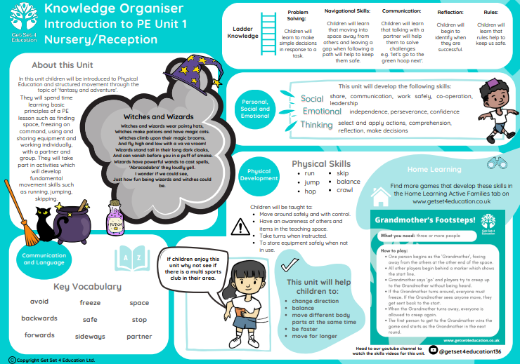 | Get Set 4 PE:  Fundamentals 1 and 2  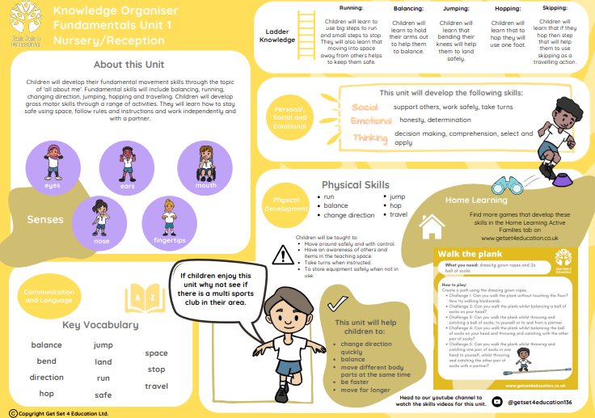 | Get Set 4 PE:  Dance 1 and 2  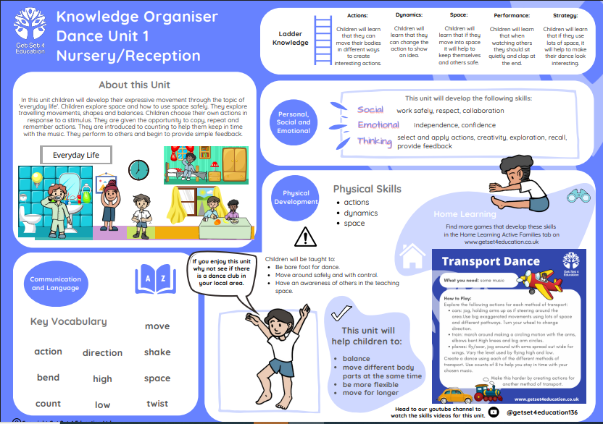 | Get Set 4 PE:  Gymnastics 1 and 2  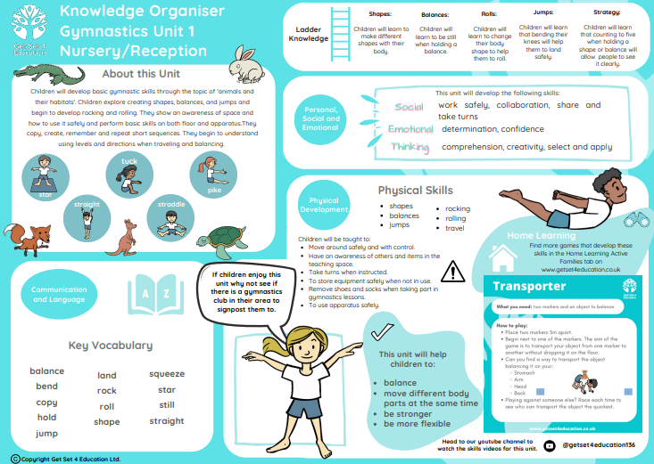 | Get Set 4 PE:  Ball Skills 1 and 2  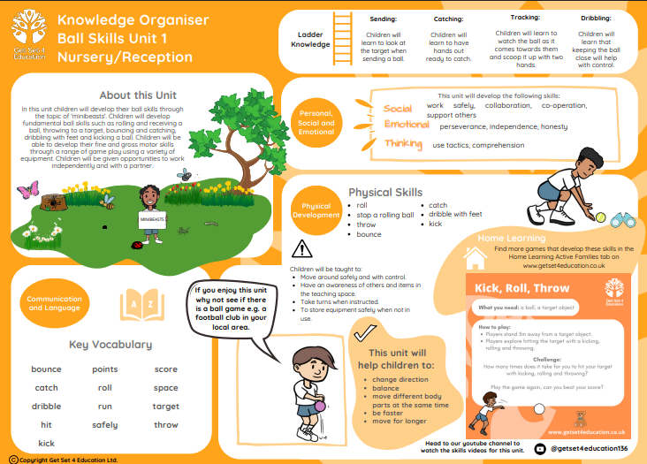 | Get Set 4 PE:  Games 1 and 2  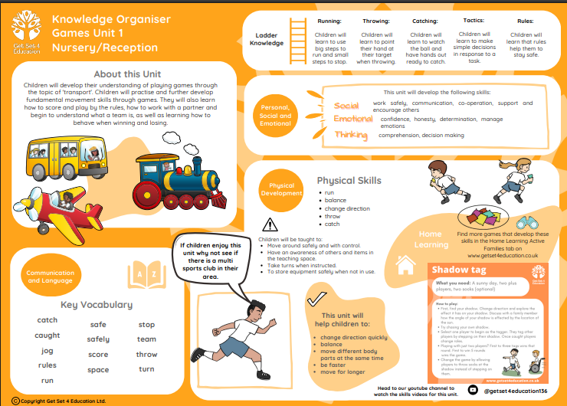
Continuous Provision:
Locomotor skills - giant pipe, loose parts for obstacle courses, hobby horses, skipping ropes, cones, den building equipment, mushrooms, stepping stones
Stability Skills – wobble board, witches’ hat, wheeled vehicles, balance walkway, stepping, river stones, foot prints, outdoor speaker
Manipulative - shopping Trolley, PE equipment, netball/basketball hoop, guttering & stands, tyres, loose parts, wheeled toys including bikes, trikes & balance bikes
Weekly ‘Balanceability’ sessions using the Balance bikes.

Mathematics | Numbers to 5  Count to 5 objects when given a set  Count out correct number of objects from a larger set.  Subitise 1 – 3, simple dice patterns  Make number collections for 1 – 5.  Make amounts of 1 – 5 on a 5 frame | Numbers to 5  Teach children to count to 5 pictures  Spot mistakes in object counting  Subitise collections of objects/pictures/dots (1-3 random arrangements)  Spot the mistakes in number collections 1- 5.  Make amounts of 1 – 5 on a 5 frame | Numbers to 10  Teach children to count up to 10 objects/pictures  Spot mistakes in object/picture counting  Subitise collections of objects/pictures/dots (1-4 random arrangements)  Make number collections for 6 – 10.  Introduce 10 frames.  Make 1 – 10 (5 wise) | Numbers to 10  Teach children to count up to 10 objects/pictures  Spot mistakes in object/picture counting  Subitise collections of objects/pictures/dots (1-5 random arrangements)  Reasoning with number collections 6-10.  Make 1 – 10 (pair wise) | Numbers to 15  Teach children to count up to 15 objects/pictures  Spot mistakes in object/picture counting  Subitise collections of objects/pictures/dots (1-5 or 6 random arrangements)  Make numbers from 10 – 15 using various objects  Make 11-15 in 5 wise and pair wise arrangements | Numbers to 20  Teach children to count up to 20 objects/pictures  Spot mistakes in object/picture counting  Revise subitising up to 5.  Make numbers from 15 – 20 using various objects  Make 15-20 in 5 wise and pair wise arrangements
Maths books  (to be read in Story time) | Earnest by Catherine Rayner  The Perfect Fit by Naomi Jones  My Map Book by Sara Fanelli  The Button Box by Margarette S. Reid  One Fox: A Counting Book Thriller by Kate Read  1, 2, 3, Animal by Britta Teckentrup | I want to Be by Tony Ross  Cubes, Cones, Cylinders & Spheres by Tana Hoban  One to Ten and Back Again by Nick Sharratt & Sue Heap  I Spy Numbers by Jean Marzollo & Walter Wick  Abigail by Catherine Rayner  How Many? By Christopher Danielson | Actual Size by Steve Jenkins  Faster, Faster!Nice & Slow! By Nick Sharratt & Sue Heap  Ruff by Jane Hissey  Ten Black Dots by Donald Crews  Kipper’s Toybox by Nick Inkpen  One Bear at Bedtime by Mick Inkpen | A Squash & a Squeeze by Julia Donldson  Martha Maps it out by Leigh Hodgkinson  10 Little Rubber Ducks by Eric Carle  Handa’s Hen by Eileen Browne  10 Little Penguins by Kate Toms  I Can Only Draw Worms by Will Mabbitt | Balancing Act by Ellen Stohl Walsh  What’s in the Witches Kitchen? by Nick Sharratt  Ten Fat Sausages by Michelle Robinson & Tor Freeman  Mr Wolf’s Week by Colin Hawkins  How to Count to One by Casper Salmon & Matt Hunt  None the Number: A Counting Adventure by Oliver Jeffers | Map My Country by Harriet Brundle  12 Ways to get to 11 by Eve Merriam & Bernie Karlin  Don’t Count Your Chickens by Simon Puttock  How Many Legs? By Kes Grey & Jim Field  Eat Your Peas by Kes Grey & Nick Sharratt  Barry the Fish With Fingers by Sue Hendra & Paul Linnett  Centipede’s 100 Shoes by Tony Ross  The Hundred Decker Bus by Mike Smith
Understanding the World  Forest School Links throughout the year. | Welly walk around school  Share ‘All About Me’ bags  People who live in my house  Visit Church (Harvest)  Changing States of matter – making toast, vegetable soup | Autumn Welly Walk  Features of Autumn  Celebrate Carnival & Bonfire Night  Celebrate Diwali – make Rangoli patterns & salt dough diva lamps  Visit to Tesco – buy ingredients  Changing States of matter – make Christmas biscuits | Spring Welly Walk – look at similarities & differences  Sort old & new toys  Talk about Florence Nightingale  Changing states of matter- water – ice activity  Celebrate pancake day. Changing states of matter – make pancakes | Visit from a chicken & a quail. Talk about similarities & differences  Look at different eggs – goose, hen, & quail.  Changing states of matter – cook eggs in different ways.  Visit NP Library  Visit Memorial Park NP  Celebrate Easter. | Plant & grow various seeds.  Observational drawings of Spring flowers (EAD Link).  Use photos to compare life in GB & other countries. Use Google Earth.  Watch ‘Where in the World?’ CBeebies  Changing states of matter – Make Pizza’s. | Summer Welly walk – look at similarities & differences.  Sequence pictures baby – 5 year old. How have they changed over time?  Changing states of matter – eat fruit and vegetable grown.  Make jelly.
UtW Books  (to be read in Story time) | Sand between my Toes by Caroline Cross  So Much by Trish Cooke  Super Duper You by Sophy Henn  What Makes Me a Me? By Ben Faulks  Emergency! By Margaret Mayo  Handa’s Surprise by Eileen Browne | We’re Going on a Lion Hunt by David Axtell  My Dad by Susan Quinn  The Best Diwali Ever by Sonali Shah  The Great Big Book of Families by Mary Hoffman  We all Have Different Families by Melissa Higgins  The Most Magnificent Thing by Ashley Spires  Puffin Peter by Petr Horacek | Mama Panya’s Pancakes by Mary & Rich Chamberlain  Family & Me by Michaela Dias-Hayes  Mum & Dad Glue by Kes Grey  Don’t Hug Doug by Carrie Finison  Izzy Gizmo by Pip Jones  Penguin Small by Mick Inkpen | The Magic Paintbrush by Julia Donaldson  An African Princess by Lyra Edmonds  Five Bears by Catherine Rayner  A World Full of Poems by Sylvia Vardell  Egg Drop by Mimi Grey  Chopsticks by Jon Berkley | Errol’s Garden by Gillian Hibbs  Angela’s Airplane by Robert Munsch  The Extraordinary Gardener by Sam Boughton  Papa Penguin by Lindsay Camp  My Must Have Mum by Maudie Smith  Commotion in the Ocean by Giles Andreae | Bea by the Sea by Jo Byatt  The Honey Hunters by Francesca Martin  The Proudest Blue by Ibtihaj Muhammed & S K Ali  Family Poems by Jennifer Curry (p16 & 37)  Waiting for the Whales by Sheryl McFarlane  Mrs Armitage on Wheels by Quentin Blake
Expressive Arts & _{Design} | Draw a picture of themselves/family  Observational drawing of a face  Explore 2 Simple Paint | Explore different marks & describe them, using various media.  Make firework pictures using chalk & black paper.  Explore colour mixing.  Make own Elmer using colours mixed.  Leaf printing & leaf rubbing. | Make observational paintings – varying the quantity of paint to create different hues.  Make own thumb pot using clay. | Make observational drawings of Spring plants (using oil pastels).  To decorate an Easter egg outline with different marks.  Making different shades of a colour.  Make a clay model that stands up. | Make a wax resist picture of an underwater scene.  Focus on Vincent Van Gogh ‘Starry Night’. Recreate a picture using thick paint.  Make observational drawings of fruit & vegetables (link to Oliver’s Vegetables).  Make a clay tile.  Make an observational model of an animal from another country. | Make observational drawings of plants.  Make a detailed, but tiny picture for a giant.  Make a painting of something from the school trip.  Create a beach scene using paper mache, to create buildings & other landmarks.
 | Sing Up Music Scheme  I’ve got a Grumpy face  The Sorcerer’s Apprentice | Sing Up Music Scheme  Witch, Witch  Row, Row, Row your boat | Sing Up Music Scheme  Bird Spotting: Cuckoo, Polka  Shake My Sillies Out | Sing Up Music Scheme  Up & Down  Five Fine Bumble bees | Sing Up Music Scheme  Down There under the sea  It’s oh so quiet! | Sing Up Music Scheme  Slap, clap, clap  Bow, bow, bow Belinda

