 | Autumn 1 | Autumn 2 | Spring 1 | Spring 2 | Summer 1 | Summer 2
Class Book Focus | 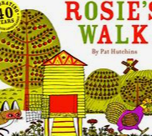 | 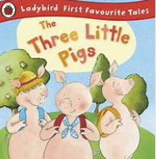 | 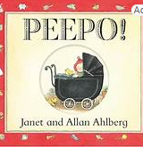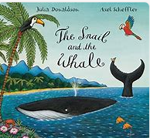 | 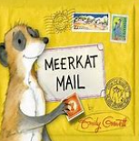 | 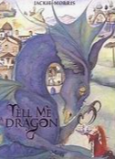 | 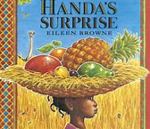
Writing | Narrative-Rosie’s Walk.  Expository Writing – Hen Fact File | Narrative-The Three Little pigs.  Expository writing- wanted poster/letter.  Autumn senses poem. | Narrative- The Snail and the Whale.  Expository writing-  rhyming poem. | Narrative- Meerkat Mail.  Expository writing- postcards. | Narrative-Tell Me a Dragon.  Expository writing- fact file  Kennings Poem. | Narrative- Handa’s Surprise.  Expository writing- instructions.
Maths | Numbers to 20  Addition/subtraction | Addition/subtraction  Capacity/Money | Place value to 50  Addition/subtraction | Place value to 100  Addition/subtraction | Multiplication/Division  Fractions | Place value to 100  Time  Addition/subtraction
Science | Everyday materials  Seasonal Change |  | Animals, including humans  Seasonal Change |  | Plants  Seasonal Change
History | How am I making history? |  |  | How have toys changed? | How have explorers changed the world?
Geography |  | What is it like here? | What is the weather like in the UK? |  |  | What is it like to live in Shanghai?
RE | What do some people believe God looks like? Lesson 2, Lesson 3 and Lesson 4 |  | Lesson 1 and Lesson 2 |  | How do we know that new babies are special?
  How did the World begin?
  Introductory lesson, Lesson 2 and Lesson 3
  Why should we care for the world?
  Lesson 3, Lesson 4, Lesson 5 and Lesson 6
  Why should we care for others?
Computing | E-safety  Computing systems and networks. | E-safety  Creating Media- digital painting. | E-safety  Creating Media- digital writing. | E-safety  Data and information- grouping data. | E-safety  Programming A- moving a robot. | E-safety  Programming B- introduction to animation.
PSHE | Me and my relationship | Valuing Difference | Keeping Safe | Rights and Respect | Being My Best | Growing and Changing
PE | Fundamentals  Team building | Gymnastics | Ball skills  Fitness | Dance | Invasions games | Sending and receiving
Art/DT | Art and Design: Drawing-making your mark  Design and Technology: Structure-making a windmill. | Art and Design: Drawing-exploring line and shape.  Design and Technology: textiles- making puppets. | Design and Technology: mechanisms- making a moving story book. | Art and Design: Painting and mixed media. | Art and Design: Sculpture and 3D | Art and Design: Craft design- woven wonders.  Design and Technology: cooking and nutrition.
Music | Hey You! | Rhythm in the way we walk and Banana rap | In the Groove | Round and Round | Your imagination | Reflect, Rewind and Replay

