

Special Educational Needs and Disability
Information report
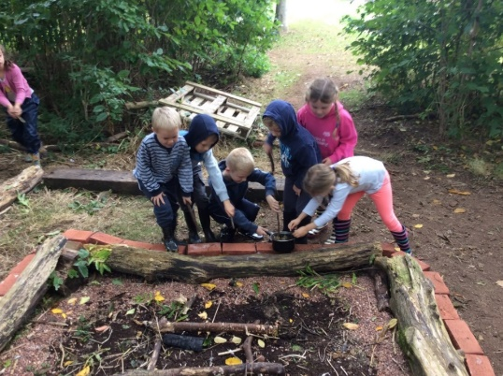

How we support children with special educational needs or disabilities
If you need a translator to help you read this, then please ask the SENDCo.
Ha fordítóra van szüksége az elolvasáshoz, kérjük, forduljon a SENDCo-hoz.
Jeśli potrzebujesz tłumacza, który pomoże ci to przeczytać, zapytaj SENDCO.
এটি পড়তে আপনাকে যদি কোনও অনুবাদকের প্রয়োজন হয় তবে অনুগ্রহ করে সেনকোকে জিজ্ঞাসা করুন

What should I do if I think my child may have special educational needs?
Please talk to us! First please ask to make an appointment to see your child’s class teacher to discuss your concerns.

Introduction
At North Petherton Community Primary School we welcome everybody into our community. The staff, governors, pupils and parents work together to make North Petherton Community Primary School a happy, welcoming place where children can achieve their full potential and develop as confident individuals. We are committed to making this happen through the attention we pay to the different groups of children within our school, thus providing a learning environment that enables all pupils to make the greatest possible progress and achieve their full potential in a caring, supportive and fully inclusive environment.


Our SEND provision allows pupils with additional needs the opportunity to follow a curriculum specifically tailored to develop life skills and to give pupils self-confidence through their learning, thus enabling them to maximise their potential and to work independently – this being linked to our school values:

All children and young people are entitled to an education that enables them to:

• achieve their best
• become confident individuals living fulfilling lives
• make a successful transition into adulthood.

Our most recent OFSTED inspection was in December 2025. The full report can be downloaded from Ofsted’s website, please click the following link for further information. Inspection Report

Somerset’s Graduated Response
Somerset’s Graduated Response Tool sets out the barriers to learning that children and young people may have and the strategies and provision that could be in place to support them.
‘Somerset’s Graduated Response Tool’ has been created to support all users to understand the Graduated Response to Special Educational Needs in the context of current legislation. The document makes it clear ‘what to expect’ in terms of what is provided and is written for parent carers, children and young people, school staff and those who provide services to families.
The tool sets out the provision that is ordinarily available in Somerset schools at both the Universal and Special Educational Needs (SEN) Support levels.

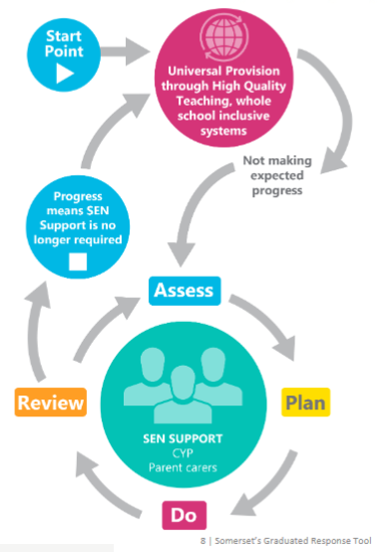
You can learn more about Somerset’s Graduated Response tool here:
Somerset Graduated Response Tool SGRT

How will the school know if my child needs extra help?
North Petherton Community Primary School is a mainstream school. We aim that:
- Children with challenges to learning are able to access their entitlement to a broad, balanced and relevant curriculum as part of the whole school community.
- Children with SEND are educated, wherever possible, in an inclusive environment alongside their peers to enable each student to reach his or her full potential.
- Levels of additional support for learning are matched to the wide variety of individual learning difficulties, while enhancing self-esteem.
- Children with SEND are assessed and identified as early and as thoroughly as possible using the revised Code of Practice (2015).
- Parents/carers and children are fully involved in the identification and assessment of SEND, and that we strive for close co-operation between all agencies concerned, using a multi-disciplinary approach.
- We meet the needs of all children with SEND by offering appropriate and flexible forms of educational provision, by the most efficient use of all available resources.
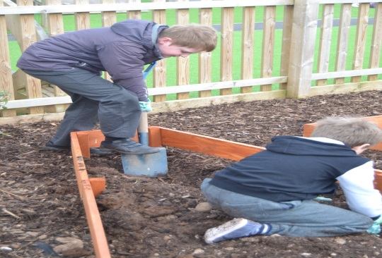
- We maintain up to date knowledge of current SEND good practice and methodology in order to offer support and training in these areas to all staff in the school.

There are four types of Special Educational Needs and Disabilities (SEND), decided by the department for education:
- Communication and Interaction (C&I)
- Cognition and Learning (C&L)
- Social, Emotional and Mental Health (SEMH)
- Sensory and/or Physical (S & P)
If your child has SEND, their needs will fit into one or more of these categories.
A school’s provision for SEND is defined as support which is additional to or different from that which is available to all children.
At North Petherton Community Primary School, we recognise that children make progress at different rates and not always in a steady linear pattern. Therefore, we would identify your child as having SEND in a variety of ways, including the following:
- Liaison with nursery/pre-school/previous school
- Your child is performing significantly below expected levels
- You as parent/carer have raised concerns
- Your child’s teacher has raised concerns
- Observation and assessments have then taken place by the school SENDCo
- Liaison with external agencies, e.g physical health diagnosis from Paediatrician
- A Graduated Response will always take place before placing a child on the SEND register
SEND identification and process
The school will use Somerset’s Graduated Response Tool and follow a graduated approach to your child’s learning; this is a process which will identify whether your child needs SEND support. During this process, class teachers, the SENDCO and other professionals involved, will follow the sequence of Assess, Plan, Do, Review. This way we can constantly aim to meet your child’s needs. As a school we will trial different strategies from the Somerset Graduated Response Tool. It is a supportive document which outlines support that your child may receive from any Somerset school at both a universal level and a SEND support level.

Somerset Graduated Response Tool
Somerset Graduated Response Tool Early Years version

How will school support my child?
Your child’s class teacher is responsible for the education of your child. In saying this, we work as a team where the SENDCo, teaching assistants and other teachers in the year group support each other to help your child achieve the best that they can. The SENDCo oversees the support and progress of any child requiring additional help across the school – working collaboratively with the child’s class teacher. Support and intervention varies and will be based on your child’s individual needs.
All children have targets that are set by class teachers based on their individual learning needs. Some children with SEND may need additional, and more specific targets to meet their needs and therefore class teachers may write Learning Support Plan (LSP). LSPs are normally shared and reviewed at parent evenings.

Support and intervention at our school includes: Class teacher input, via excellent targeted classroom teaching (Quality First Teaching). For your child this would mean –

- That the teacher has the highest possible expectations for your child and all pupils in their class.
- That all teaching is built on what your child already knows, can do and can understand.
- That different ways of teaching are in place, so that your child is fully involved in learning in class. This may involve things like using more practical learning.
- That specific strategies (which may have been suggested by the SENDCo) are in place to support your child to learn.
- Your child’s teacher will have carefully checked on your child’s progress and will have decided that your child has a gap or gaps in their understanding/learning and needs some extra support to help them make the best possible progress.
Specific group work
Interventions may be run in the classroom or a group room and taught by a teacher or a teaching assistant (TA). These vary according to the needs of the child e.g. from a set phonic support programme, pre-teaching of maths, to sessions on managing friendships – they vary considerably! If you would like to know more information about an intervention, then please ask your child’s class teacher.
Specialist intervention overseen by outside agencies, e.g. Speech and Language therapy

This means a pupil has been identified as needing some extra specialist support in school from a professional outside the school. This may be from Local Authority Support Services, such as the Access to Inclusion Team, Occupational Therapy, Speech & Language, Education Psychology Service etc.
What could happen:

You may be asked to give your permission for the school to refer your child to a specialist professional, e.g. a Speech and Language Therapist or Educational Psychologist. This will help the school and you to understand your child’s particular needs better and be able to support them more effectively in school. This will be done through meeting with the SENDCo and may require completing an Early Help Assessment (EHA) which is a document that children, parents and all professionals involved, can contribute to ensuring that all views are considered and information shared. The specialist professionals will work with the school and your child to understand their needs and make recommendations as to the ways your child is given support.

EDUCATION AND HEALTH CARE PLAN (EHCP)

Most children and young people with Special Educational Needs and/or Disabilities will have their needs met in local mainstream early years settings, schools or colleges through SEND support offered as part of the school’s own provision. Somerset’s Graduated Response Tool provides information on how education settings can provide this support.
An Education, Health and Care needs assessment may be required for children and young people with SEND aged 0 to 25 if the following apply.
The child or young person:
- Has severe and/or complex long-term needs
- Requires provision and resources which are above those ordinarily available in their educational setting
- Requires intensive and longer-term help and support from more than one agency
- Is making limited or no educational progress, despite evidence of high levels of support and purposeful interventions
When a child is demonstrating a significant cause for concern, and despite having taken relevant and purposeful action to identify, assess and meet the SEND of a pupil using APDR process, their learning need is more complex and persistent than can be met by the interventions already put in place, a statutory assessment may be considered. The below checklist is something SENDCos provide with a request from school. It can be a useful document to look at if you believe your child meets the criteria above and are a parent considering if your child needs an EHCP.
Checklist of evidence needed for EHCP process
Parents or school can request an EHCP assessment. An EHCP is a legal document that describes a child or young person's special educational, health and social care needs from birth to 25 years old. It explains the extra help that will be given to meet those needs, and how that help will support the child or young person to achieve what they want to in their life. The outcomes agreed in the EHCP are formally reviewed alongside Parents/Carers at least once a year in the form of an annual review.

How will the decision be made about what type and how much support my child will receive?
The class teacher, the SENDCo and Senior Leadership Team will discuss your child’s needs and what support would be appropriate often (but not exclusively) as part of ‘pupil progress meetings’.
Different children will require different levels of support in order to help them make progress and achieve their potential.
How will the school judge what impact the support has had on my child?
If the support has been academic:

- As a school we measure children’s progress in learning against national age related expectations.
- The class teacher continually assesses each child and notes areas where they are improving and where further support is needed. We track children’s progress from their admission through to Year 6, using a variety of different methods, including assessment under the National Curriculum and some standardised tests, as appropriate.
- Children who are not making expected progress are identified through the termly Pupil Progress Meetings. In this meeting a discussion takes place about those pupils experiencing difficulties and what further support can be given to aid their progress. The impact an intervention has had is recorded and used to make decisions about where to go next.

When a child’s Learning Support Plan (LSP) is reviewed, comments are made against each target to show what progress has been made. If the child has not met the target, the reasons for this will be discussed, then the target may be adapted into smaller steps or a different approach may be tried to ensure the child does make progress.


What opportunities will there be to discuss my child’s progress and who will explain my child’s needs and progress to me?
We aim that your child’s education should be a partnership between parents and teachers therefore we aim to communicate with you regularly.
- Your child’s class teacher and/or SENDCo will meet with you at least on a termly basis (this could be as part of parents’ evening) to discuss your child’s needs, support and progress.
- If your child has complex special educational needs or a disability they may have an Education, Health Care Plan (EHCP), and you will be invited to a formal meeting which will take place annually to review your child’s progress.
- You are also welcome to make an appointment to meet with your child’s class teacher and/or the SENDCO at any time to discuss any concerns or how well your child is getting on.
What is the pastoral, medical and social support available in the school to ensure my child’s overall well-being?
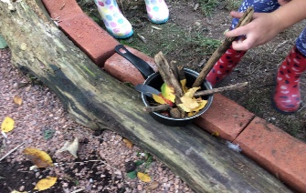
We have a caring, understanding ethos and are an inclusive school; we welcome and celebrate diversity, and believe that high self-esteem is crucial to children’s well-being. We follow a ‘trauma-informed’ approach and all staff have had training in using trauma informed approaches.

- We operate a ‘meet and greet’ system at the door of your classroom where teachers greet each child as they come into school.
- The class teacher has overall responsibility for the pastoral, medical and social care of every child in their class, therefore this should be your first point of contact. If further support is required, the class teacher liaises with the SENDCo for further advice and support. This may involve working alongside outside agencies such as Health and Social Services.
- We normally offer a range of additional provision to support children with SEND including additional Forest School and targeted lunchtime club activities if necessary. We also access off-site facilities for activities such as horse riding if appropriate.

- The school encourages peer support and a ‘buddy system’ for our more vulnerable children, as well as the availability of staff members for those children who need additional pastoral care.
- Two of our TAs are trained ‘Emotional Literacy Support Assistants’ - ELSAs.
- One staff member is trained in ……….
How will my child be included in activities outside the classroom including day and residential trips?
- We aim for all children to be included on school day trips and residential stays. We will provide necessary adaptions, (reasonable adjustments) having consulted with you, to ensure that this is successful.
- A risk assessment is carried out prior to any off-site activity to ensure everyone’s health and safety will not be compromised. In the unlikely event that it is considered unsafe for a child to take part in an activity, then alternative activities will cover the same curriculum areas provided in school. We will always explore different options to try and include the child and will discuss this with you.
How does the school manage the administration of medicines and personal care? 
- We have a policy regarding the administration and management of medicines on the school site.
- Parents need to contact the school office if medication needs to be taken during the school day and the appropriate forms need to be completed.

- If a child’s health care needs are longer term, a medical or health care plan will need to be put in place. This is sometimes provided by the healthcare professionals, but we will invite you into school to clarify the plan.
- Staff receive regular training regarding conditions and medication affecting individual children so that all staff can manage a medical situation should the need arise.

- If a child requires personal care, a plan will be out in place and staff will have undergone the appropriate training to undertake this level of care.
What support is there for behaviour, avoiding exclusion and increasing attendance?
We have a positive approach to behaviour management with a clear behaviour policy that is followed by all staff and pupils. We are an inclusive school and we make every effort to include all pupils in learning sessions with their class. We also take every opportunity to include pupils socially at break and lunch times.
- The attendance of every child is monitored on a daily basis at present by the school attendance lead and the Head and Deputy Head. Lateness and absence are recorded and reported to the Head teacher and governing body.
- If a child is at risk of exclusion a Pastoral Support Plan (PSP) is written with the child and parents to identify the specific issues and reflect the relevant support and targets in place.
- After any serious behaviour incidents, we will inform you about what has happened. A restorative conversation would take place at some point after the incident to to help the child to reflect upon their behaviour with you; this helps to identify why the incident happened and what the child and adults need to do differently next time.
What specialist services and expertise are available at or accessed by the school?
- We work closely with any external agencies that we feel are relevant to individual children’s needs within our school. These may include: GP, School Nurse, Educational Psychologist, Paediatrician, Speech & Language Therapist, Occupational Therapist, the Access to Inclusion Team, the Physical Impairment and Medical Service (PIMS) the Child and Adolescent Mental Health Service (CAMHS)
- We also work with a range of further services including the Family Intervention Service and Children’s Social Care (including the Children’s Disability Service, and Social Workers).





How accessible is the school environment?
- Both the Mendip and the Quantock sites are wheelchair accessible.
- There are 4 disabled toilets, which are large enough to accommodate changing and personal hygiene care and two have shower facilities. One disabled toilet is fitted with a ceiling hoist.
- There are several shaded areas within the playground areas to support pupils with light sensitivity.
For further information, please refer to the school’s Accessibility Plan
How will the school prepare and support my child when joining the school or transferring to a new school?
- We encourage all new children to visit the school prior to starting with us.
- For children with special educational needs or a disability we may facilitate a phased transition to help your child to acclimatise to their new surroundings. We would also visit them in their current setting if appropriate.
- We write social stories with children to help explain and prepare them for any major transition.
- We liaise closely with staff when receiving and transferring children to different schools, ensuring all relevant paperwork is passed on and all needs are discussed and understood.
- If your child has an Education and Health Care Plan and is changing to a new school we will, whenever possible, arrange a review meeting with relevant staff from the receiving school.
How are the school Governors involved, and what are their responsibilities?
- The SENDCO reports to the governors annually to inform them about the progress of children with SEND; this report does not refer to individual students and confidentiality is maintained at all times.

One of the governors is responsible for SEND and meets with the SENDCO. This ‘SEND link governor’ also reports to the governing committees, to keep all the governors informed.
How can I get additional support, outside of school?
Somerset Parent Carer Forum is an independent group of parent carers who have joined together to share information, their views and experiences of the children’s / young person’s services (0-25 yrs) they already use or would like to use in the future.
Phone: 01458-259384 email: admin@somersetparentcarerforum.org.uk Website: https://somersetparentcarerforum.org.uk/

Somerset SENIDAS is an organisation that provides independent advice and support for families
Phone: 01823 355 578 email: somersetsendias@somerset.gov.uk Website: https://somersetsend.org.uk/

Who should I contact if I am considering whether my child should join the school?
Contact the school office, to arrange a meeting and tour of the school.
- If your child has a Special Educational Need or a Disability, you could contact the SENDCo who will discuss how the school could meet your child’s needs.
Phone: 01278 662442 email: office@npcps.co.uk or sendco@npcps.co.uk

School SENDCo: Nic van Cole
This document was updated in December 2025 by the SEND governor and the SENDCo.

